TYPED REVISION PHILOSOPHY

1. **Define the term philosophy of education**

*Aplication of philosophy to the issues of education, e.g.*

* *examining definitions,*
* *examining goals and objectives*
* *Critically analysing meaning of terms*

1. **4 reasons why studying philosophy of education is useful to teachers**
2. *To develop a personal philosophy of education from the perspective of teacher*
3. *Appreciate/understand the role of the teacher*
4. *Appreciate differences of opinion*
5. *Understand knowledge*
6. *Know how to make logical presentations*
7. *Learn how to think critically*
8. *Influence lives positively*
9. **identify and explain styles of philosophy**

* **Speculative**: *To speculate is to think, guess, consider, wonder, hypothesize. Philosophy is speculative when it raises questions about the ultimate nature of being and thought.*
* **Prescriptive:** *To prescribe means:*

1. *to recommend*
2. *to stipulate*
3. *to advice*
4. *giving directions, rules, or suggesting*

It examines the meaning of: good and bad, right and wrong, beautiful and ugly.

**Analytic:***Making Logical thinking, Reasonable judgement*

1. *Being investigative*
2. *Being critical*
3. *Being rational*
4. *Being methodical*
5. *Being analytical*

**Phenomenological:** It’s addressing the meaning that things have in our experience.

1. **5 ways in which understanding of logic maybe useful to you as a teacher**
   1. *Logic helps in the formulation of objectives that are consistent with the needs of the country.*
   2. *It helps the teachers to think systematically and logically during:*

*Scheming*

*Lesson planning*

*Lesson presentation*

* 1. *Helps in coming up with teaching methodologies which promote logic such as: experimentation, discussion, debate, brain storming, etc.*
  2. *Arrangement of topics in the syllabus in a sequential manner.*
  3. *Proper sequencing of topic in the scheme of work and the lesson plan.*
  4. *Consistence in presentation*
  5. *In clarifying and convincing*

1. **5 principles of perenialism and how it has influenced education in Kenya**

*1] Education has a task of to impart knowledge of eternal truth. The truth is the same everywhere.*

*2] Despite differences in environment human nature remains the same everywhere. Thus, education should be the same for everyone.*

*3] Education is not an imitation of life but preparation for life. The school can never be a real-life situation, nor should it be. School is an artificial arrangement in which learners become acquitted with achievements of his cultural heritage. Learner’s task is to realize the value of his heritage and if possible, add to its achievements through his/her effort.*

*4] Since rationality is man’s greatest attribute, he must use it to direct his inner nature in accordance with deliberately chosen ends.*

*5] The students should be taught certain basic subjects which will acquaint him/her with the world’s permanence. The student should not be allowed to learn things that seem important at the current time, nor should students be allowed to learn what appeals to him/her at a particular age.*

*Student should study English language, History, Mathematics, Natural science, philosophy and fine art. This is the basic education of a rational man.*

*6] Students should study the great works of literature, philosophy, history and science in which man throughout the ages have revealed their greatest aspiration and achievements. The message of the past* *is never outdated.*

1. **3 conditions of knowledge**

* ***Truth****: a fact or belief that is accepted as true*
* ***Belief****: an acceptance that something exists or is true, especially one without proof.*
* ***Justification****: good reason for something that exists or has been done.*

1. **Describe 3 types of knowledge**
   1. ***Empirical knowledge*** *:*

*This type of knowledge is attained from qualitative or quantitative observations, experiments, or measurements. The term empirical is derived from the Greek word “Empeiria”. The meaning of “Empeiria” is experience in the Greek language. Empirical information can be used to verify the truth or to prove the falsity of an argument*

* 1. ***Factual Knowledge:*** *This is the information that can and must be learned through exposure, repetition, and commitment to memory*
  2. ***Conceptual Knowledge****: knowing the interrelationships and/or functions among the details and elements that make up a larger structure. This definition includes (1) knowing information classification and categorization, (2) knowing principles and generalizations, and (3) knowing* *theories, models, and structures. Basically, conceptual knowledge is knowing that facts can be organized in meaningful ways. Taking the example of a business marketer, it is not enough to know the details of his or her products or services and that of the competition. There must be conceptual knowledge of the differences and the meaningful competitive advantage of one over another.*
  3. ***Tacit Knowledge****: It is sometimes referred to as know-how. and refers to intuitive, hard to define knowledge that is largely experience based. Because of this, tacit knowledge is often context dependent and personal in nature. It is hard to communicate and deeply rooted in action, commitment, and involvement*
  4. ***Propositional Knowledge*** *(also Descriptive or Declarative Knowledge): to is knowledge that can literally be expressed in propositions; that is, in declarative sentences or indicative propositions.*
  5. ***Procedural Knowledge:*** *is knowledge that can be used; it can be applied to something, such as a problem. Procedural knowledge differs from propositional knowledge in that it is acquired “by doing”; propositional knowledge is acquired by more conservative forms of learning.*

**Q1a) Define philosophy**

Philosophy therefore means: ***Search for wisdom***

***or***

Philosophy ***is a reflective and critical thinking about concepts and principles used to recognise our experience in moral, social and political life***

1. **Explain various Sources of philosophy**
2. ***Events of the world****—these are the events that interferes or challenges our normal life. i.e. drought, flood, plane crash….i.e. what makes a place to be a desert while others be a forest, is it human activities and how can one reserve the flood and reuse it later.*
3. ***Human predicament****--- unfortunate challenge that human being face. i.e. selling land for one’s child to go to school only to find that the child become a drunker.*
4. ***Wonderment****. --- having a feeling of surprise. i.e. why do sun rises from east and set at west and where are the origin of all these, the sun, the moon, the stars.*
5. ***Methodological doubt****--- we believe as philosophers that no one should believe anything unless proven beyond doubt*
6. ***Facts about human experience***

*….when man go through experience, we learn more. These may include, suffering, death, struggle, guilt.*

*These experience improves on the lives and also improves our knowledge.*

**Importance of learning philosophy**

1. *Helps the teacher/trainer to know the* ***extent of authority*** *over the learners*
2. *It equips the teacher/trainer with ability to influence education problem by offering alternatives solutions*
3. *It encourages a teacher/trainer to look at education problems more critically*
4. *It enables a teacher/trainer to stimulate international interest of the learner, because the trainer allows the student to ……*
5. *It helps a teacher to understand their roles in teaching and learning process. i.e. identify the right methods of delivering the content and requires the right resources.*
6. *It makes a teacher to be aware of implications of various issues involved in education*
7. *Philosophical analysis enables a teacher to examine the underlying meaning of word commonly* used in education and therefore be able to define concepts and terms to learners/students

**ii)Differentiate between General and Technical Philosophy**

***General*** *Refers* ***to traditional philosophy*** *which was common in traditional societies. General philosophy is in the form of* ***Legend, myths, stories, taboos, songs*** *etc*

**Technical philosophy -** Technical philosophy tends to understand and answer questions to ***all aspects of existence and universe***

**Explain Components of General Philosophy**

1. ***Personal philosophy-*** belief/values and assumptions which influence their way of life. i.e. choice of dressing
2. ***Community philosophy-*** Community is a group of people bound together by common characteristics e.g. Customs, family lineage, faith, education
3. ***National philosophy-*** asset of beliefs/Convictions and values that constitute a countries general philosophy e.g. Kenya: *Harambee Philosophy and Nyayo Philosophy*

***d. International philosophy-*** International (UN)- Peaceful world (No any other world War), Education for all, World health organisation (WHO)- world free of polio etc

**Q2. Explain the four Functions (styles) of Philosophy and state relevance to education**

**a) Speculative functions-**guess, consider, hypothesis

- philosophy is speculative when it raises questions about the ultimate nature of being and thought- People want to explain *sickness, death, calamities etc*

**Relevance of speculative philosophy to education**

* It is used to establish theories
* It is important to interpret researches
* Judging quality standards(quality assurance)
* Examines the Nature of man
* It looks at How the environmental influences in education
* How education influences the environment
* Helps to plan for future
* Assist in developing an open mind

**b) Prescriptive philosophy-**To prescribe is to mean, to recommend**,** to stipulate**,** to advice**,** to give direction, rules or suggestions

Prescriptive functions, examines the meaning of:

*-good or bad*

*-Right and wrong*

*-Beautifully and ugly*

It aims at liberating man from narrow mindedness by:

**Relevance of prescriptive functions to educations**

**Prescriptive functions:**

* *helps the choice of right objectives of education*
* *provides the criteria of choosing*
  + *methodology*
  + *values*
  + *procedures of education*
* *Helps in determining the worthiness of content of education*
* *helps to develop open minded scholars*
* Helps to set standards of evaluations
* helps in setting rules and regulations

**c) Analytic functions-**Analytic functions refers to:

1. *Logical thinking*
2. *Being critical*
3. *Being rational*
4. *Being methodical*
5. *Being analytical*

Analytical functions helps to:

* Remove ambiguities and vagueness
* Explain the meaning of terms and expressions

**Relevance of Analytic functions to educations**

Analytic functions are important in that:

* *Helps us better understand the meaning of our present ideology*
* *usefulness in the classification of terms and concepts in education*
* *Ensures a meaningful approach to the education process*
* *Very useful in research (literature review)*
* *important in rationalizing*

1. **Phenomenological functions**

Phenomenological functions of philosophy addresses the meaning that things have in our experiences i.e. Things as they appear in our individual experience, significance of objects, events, tools, the flow of time to self and others, The study of phenomena things as experienced in our life world as an individual

**Relevance of Phenomenological functions to education**

*i)assist in the analysis of experience*

*ii)Helps understand individuality of the learner*

*iii)learning experiences differs from learner to learner*

iv)teacher should strive to meet individual learners needs where possible

v)helps learner to develop self-consciousness

*vi)considerations of individuality in thinking, acting etc*

*vii)helps teacher plan for social learning i.e. collective activities*.

**ASSIGNMENT ON STYLES (SPAP)**

**Identify the Style of philosophy being applied in this statement**

1. Students trying to define concept in Biology.

* *Analytic*

1. Teaching the Theory according to Taylor

* *Prescriptive*

1. Developing hypothesis for a research problem.

* *Speculativ*e

1. Recommending the most effective method of teaching mathematics.

* *Prescriptive*

1. Thinking about the ways of meeting each individual needs in class.

* *Analytic*

1. Grouping students according to their individual ability.

* *Phenomenological*

1. Guiding students on the behavior that is acceptable.

* *Prescriptive*

1. Asking learners to give their own opinions on some issues.

* *Speculative*

1. Thinking through an issue in education.

* *Phenomenological*

1. Deciding on the discipline to be given to those who cheat in examinations.

* *Prescriptive*

**Reflective activities**

**ASSIGNMENT**

**a) How does knowledge of styles? functions of philosophy assist a teacher in the teaching process**

**b) Is it possible to be an effective teacher/trainer without the knowledge of the styles of philosophy?**

**Q3) State the Branches of Philosophy (MEAL)**

1. *Metaphysics*
2. *Epistemology*
3. *Axiology*
4. *Logic*
5. **Briefly explain each of the branches above**
6. **Metaphysics-Deals with things of** *nature/beyond the physical world,things that do not change*

*Deals more with;*

* 1. *the abstract*
  2. *nature of the human mind*
  3. *concept of being*
  4. *existence*
  5. *nature of space and time*

**Metaphysics is divided into four parts;(PROCT)**

1. **Ontology**
2. **Cosmology**
3. **Theology**
4. **Rational or Philosophical Psychology**
5. **Ontology**-It is the study of ‘Being’ - ‘Existence’ – ‘Reality’

*Suggests unchanging essential reality*

*That matter is not destroyed but only changes state*

*Ontology is also the study of how we determine if things exist or not*

*All things, dead or alive, have one thing in common, ‘being*

1. **Cosmology**

*This deals with the study of the universe (cosmos).*

*Early philosophers were confronted with many myths concerning the origin of the universe.*

*each myth needed to be explained rationally, both scientifically (physically) and philosophically e.g Planet,Solar system,Galaxy ,Universe*

*Solar System*

*This leads to many questions*

* *Who created all of this*
* *How powerful and intelligent the creator of all of this must be*
* *Where did the universe come from really*
* *Where are we going*
* *Why/how have some stars disappeared*

**c). Theology**

*This is the philosophical study of the supernatural/religious matters.*

*It is the rational study of God (from a point of reason)*

**It looks into issues such as;**

* *who is God*
* *what is the spirit*
* *is heaven real*
* *are the human beings on earth the only beings in the universe*
* *could the things we think of that are not physical/real be in existence*

**d) Rational or Philosophical Psychology**

***Study of the ‘psycho’ which is the Greek word for ‘soul’***

***Studies man as having a body and a soul***

***Starts by being aware that man;***

* + *perceives,*
  + *imagines,*
  + *remembers,*
  + *feels,*
  + *understands and*
  + *Wills.*
* **tries to find the relationship between the mind/soul and the body,**

**Relevance to Education**

1. *Important in the study of astronomy, and the general study of the universe (where we belong)*
2. *It helps to develop a mind that goes beyond fanaticism and embraces reason in the face of religion*
3. *It develops the individuals’ tolerance to the views of others.*
4. *It helps develop a creative mind, able to imagine tomorrow and bring the non-existent into existence.*
5. *It helps in the identification educational;*

* objectives
  + content
  + methodology
  + evaluation

**Necessary for the development of the mind, body and spirit**

**Epistemology**

*Epistemology is the philosophical study of knowledge*

*Concern with the meaning and justification of the facts of knowledge that other subjects put across*

*Epistemologically philosophers will question knowledge, and such questions you may have include:*

* *What is epistemology about?*
* *How is knowledge attained?*
* *What should be believed?*

**Gathering (Acquiring) knowledge**

**a) Empiricism Theory**

* *Is the theory that the only source of human knowledge is experience*
* *That experiments and observation are the main instruments for the acquisition of knowledge.*
* *Empiricism accepts that there is some innate ( ie inborn )or a priori*

**(i.e. gained earlier) knowledge in humans**

**b) Positivism Theory**

1. *That knowledge is innate*
2. *that humans can acquire knowledge of a special sort, called "a priori knowledge“*
3. *Gained independently*
4. *Not related to any experience*
5. *Compromise*

**Relevance to Education**

1. *Helps define knowledge*
2. *Helps understand the sources of knowledge*
3. *Concerned with the order and presentation of knowledge*
4. *Questions the importance of the knowledge being presented*
5. *Establishes the aspect of conviction in the knowledge presented.*
6. *Projects into the future of knowledge*
7. *e.g. artificial intelligence*
8. *Visualize the curriculum in the age* of AI
9. **Axiology**

*Axiology therefore deals with the nature and types of values, e.g. morals,*

* + *Aesthetics*
  + *Ethics*
  + *Religion*
  + *Political*
  + *Cultural*
  + *metaphysics*

**Axiology is the scientific system of identifying and measuring value**.

* **It is the filtration system a person uses to;**
* **think**
* *Leads to the development of ;*
  + *personality,*
  + *individual perceptions, and decisions. In common parlance,*
  + *individual structure of values*

**Types of values  
 1. Aesthetics**

*Deals with Beauty as perceived in;*

* *fine arts,*
* *music,*
* *literature,*
* *architecture,*
* *landscape, etc.*

*Philosophers appreciate that this is in the eye of the beholder, but are mainly concerned with what may influence the same.*

*The following may arise;*

*What really is beauty?*

*Beautiful to who?*

*Beautiful when?*

*Who decides the degree of beauty*

*Should/does beauty last?*

**2. Ethics**

*Refers to principles that define behavior as;*

* + *Right/wrong*
  + *Good/bad*
  + *Proper/improper*

*Such principles do not dictate a single "moral" course of action, but provide a means of evaluating and deciding among competing options.*

*Ethics is concerned with how a moral person should behave, whereas values are the inner judgments that determine how a person actually behaves.*



**Sources of Values**

* *Family*
* *Friends & peers*
* *Community or society*
* *School*
* *Media*
* *Relatives*
* *Organization*
* *Religion*
* *History*
* *Books*

**Relevance to Education**

1. *Identify values that are relevant in education*
2. *Identifying and defining educational goals and objectives*
3. *Helps in choosing the correct methodology*
4. *Useful in deciding on the relevance or value of the education provided*
5. *Appreciation of other people and their lives/views (political or otherwise)*
6. *Appreciation of beauty (school beautification)*
7. *‘Organizing’ oneself*

1. **Logic**

*The study of the principles of correct reasoning*

*There are many such principles, but most importantly are principles governing the validity of arguments*

*Illogically reasoning leads to wrong conclusions and unwarranted generalizations*

*Logic provide rules and regulations that should be followed in the process of reasoning.*

*A logical discussion convinces*

**Classifications of Logic**

**a)Deductive reasoning**

**b) Inductive reasoning**



**a) Deductive reasoning**

*This is the reasoning that starts from general principles or axioms (premise)*

*From the general, certain conclusions are deduced / arrived at.*

*Such reason is expressed in the form of a syllogism, ie reaching a conclusion from two statements. For instance;*

*All government workers are corrupt.*

*James works for the government.*

* + *Therefore he is corrupt.*

*A deductive argument is said to be valid when the inference from premises to conclusion is perfect. Here are two equivalent ways of stating that standard:*

*If the premises of a valid argument are true, then its conclusion must also be true.*

*It is impossible for the conclusion of a valid argument to be false while its premises are true****.***

*b) Inductive reasoning*

*This is the reasoning that starts from a particular observation and ends up with a general conclusion.*

*Many observations are necessary, to be able to come up with a conclusion.*

*It is the kind of reasoning that does not guarantee complete certitude.*

*For instance one may observe that,*

*“civic leaders in Kenya have very little formal education.”*

*This will mean that one collects data from at least 70% of the townships in Kenya so as to make a valid conclusion.*

*The greater the number of observations, the stronger the conclusion to be made.*

***Remember that deductive arguments claim to guarantee their conclusions, while inductive arguments merely recommend theirs***

**Relevance to Education**

1. *Logic helps in the formulation of objectives that are consistent with the needs of the country.*
2. *Arrangement of topics in the syllabus in a sequential manner.*
3. *Proper sequencing of topic in the scheme of work and the lesson plan.*
4. *Consistence in presentation*
5. *In clarifying and convincing*

**FOOD FOR THOUGHT**



**Discuss five ways in which the understanding of the branches of philosophy will improve your effectiveness as a trainer.**

**RESPONSE**

From the respective Branches of Philosophy. I will be able to develop as discussed below:

**a) Knowledge of metaphysics will enable me to:**

1. Develop my reasoning and have tolerance to other people’s ideas/opinion.
2. Develop a creative mind and be able to imagine things and bring the non-existent thing into existence.
3. Identify :

                 -educational objectives

                 -content to be taught at various levels

                 -methodology to use deliver content

                 -appropriate evaluation for holistic person

**b) Knowledge of epistemology will enable me to:**

1. Know the process of acquiring knowledge.
2. Identify the sources of knowledge e.g. scientific inquiry, perceived knowledge [gained by our senses of smell, hearing, sight, feel], knowledge gained from systematic reasoning or logic.
3. Come up with various types of knowledge such as empirical knowledge, rational knowledge, sacred knowledge, etc.
4. Choose appropriate strategies and methods in delivery of knowledge to learners.  E.g. empirical knowledge encourages scientific methods, while rational knowledge encourages systematic reasoning. [Q & A methods]

C). **Knowledge of Axiology will enable me to:**

1. Identify values that are worthwhile to education.
2. Come up with appropriate methods to be used in education: experiments, discussion, role play, etc.
3. Know aims and objectives to be achieved in education.
4. Gain guides discipline during learning process by establishing rules and regulations.

**4] Knowledge of Logic will enable me to:**

1. Deal with issues conclusively, i.e. solving problems [moves from assumptions to valid conclusion].
2. Encourage ability to make informed choices.
3. Bring clearer understanding of conclusion.
4. Encourage discovery of new things.
5. Encourage remembering because one can see the connection
6. think systematically and logically during:

* Scheming
* Lesson planning
* Lesson presentation

1. Come up with teaching methodologies which promote logic such as: experimentation, discussion, debate, brain storming, etc.

**DIFFERENCES BETWEEN EDUCATION AND TRAINING**

|  |  |
| --- | --- |
| **Education** | **Training** |
| 1] Education imparts our way of thinking and joins individual’s mind with a wider system of beliefs.  A person is able to respond in different way to situations that confront them. Individual is in a position to handle situations that confront them in an intelligent and intellectual manner. | 1] Trained mind responds in a certain pre-determined way and has defined ways of solving problems.  An individual is conditioned to respond in a certain manner. A trained person may fail to respond to a new situation or strange situation. |
| 2] Education puts a person in a position of awareness. An educated person is aware of situations and responds if called upon to do so. | 2] Training equips a person with techniques of handling particular situations. |
| 3]Education is concerned with an **individual’s total personality** development**.** The main objective of education is to develop one’s personality. | 3] Training is concerned with only one aspect of a person’s life. E.g. It equips an individual with a **psychomotor s**kill. |
| 4] *Education is a long life process.* | 4] **Training takes a specified period** of time.  E.g. 2 years, 4 years, etc |
| 5] Education implies linkage with a wide system of knowledge.  A person must have knowledge in a number of subjects in order to be educated. | 5] Training involves the development of a particular skill or group of skills or competence in particular area of specialization.  There is element of specialization in training. [thorough knowledge in a specific area] |
| 6] Education aims at ensuring that an individual has acquired skills, knowledge and attitude to properly integrate into the community. It prepares a person to be a generally acceptable member of the society. | 6] Training involves habits of thought in relation to boss and workmates. |
| 7] Education has in-built value criteria.  Therefore a person cannot be educated if he/she has undesirable qualities. | 7] Training is value free or value neutral. E.g.   We can have a well-trained thief. |
| 8] Education leads to performance of specific tasks as well as position of awareness. | 8] Training leads to acquisition of knowledge and skills for the performance of a specific task. |
| 9] Education puts a person in a position of awareness.  Educated person is aware of the situation and can respond in different ways. | 9] Training put a person in a position of self-reliance.  A person can perform certain task to enable him/her earn living. |
| 10] Education is acquisition of knowledge, skills and attitudes by learners in order to achieve full potential in all aspects of life. | 10] Training involves teaching, drilling or discipline by which the power of mind and body are developed. |

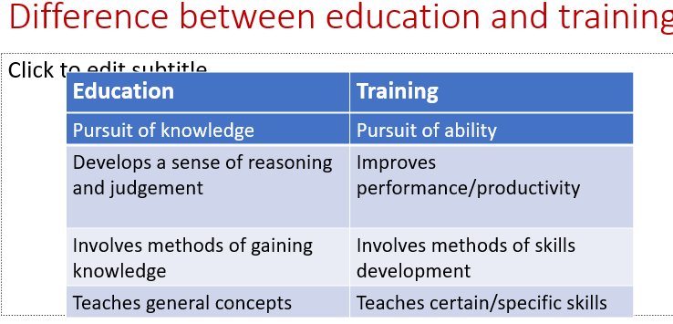

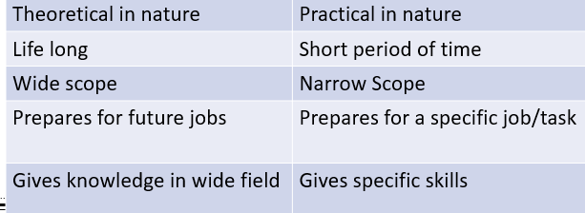

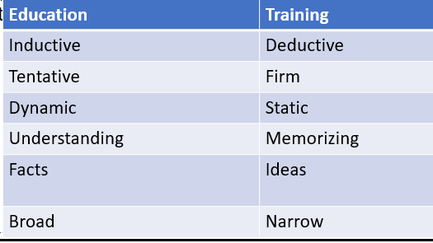

**DIFFERENCES BETWEEN EDUCATION AND SCHOOLING**

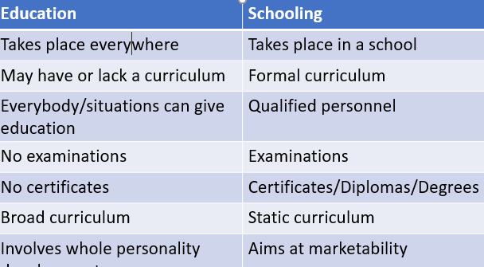

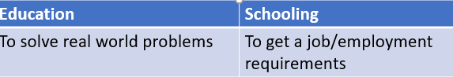

Education and indoctrination

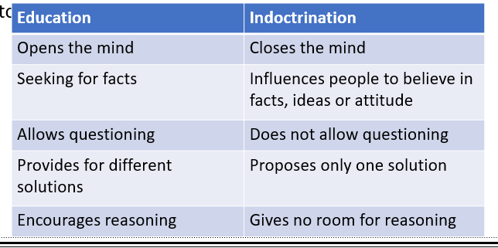

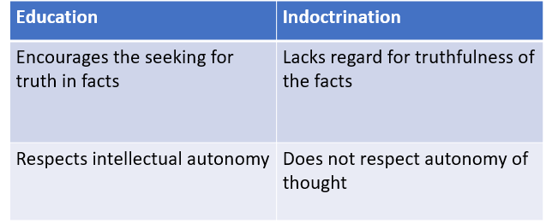

* Intrinsic value of education:
* knowledge
* wisdom
* concepts
* A desired end

**Instrumental value of education**

*It tries to analyze the value attached to education.*

*Value for the end results gained from education (means to an end).*

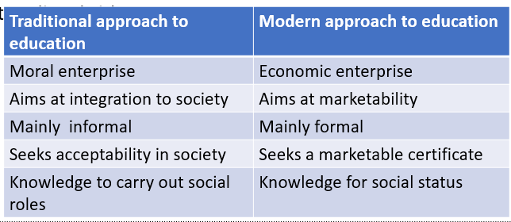

**REFLECTIVE ACTIVITY**

*What are the consequences of the instrumental value of education?*

*Does our education system promote more of education or schooling?*

**ASIGNMENT**

**Use the internet to identify ten (10) philosophers. Write down five (5) things they said which are being used in education today. (Present your work in a table)**

**RESPONSE**

|  |  |
| --- | --- |
| **NAME OF PHILOSOPHER** | **CONTRIBUTION IN EDUCATION** |
| 1. **Pestalozzi**   Born in Zurich in the year 1746 | Arithmetic is most important because it is based on sensory experience  that music would be the key to a moral education because in his words "music speaks to the heart  Drawing expressed the individual’s talent.  Language was also important in order for students to express their feelings and beliefs.  Contributed much on learning. That students need to learn in a free environment which is less restrictive. |
| **2.John Dewey**  was born in 1859 in Burlington | education was “a crucial ingredient in social and moral development”  He believed that traditional education as just described, was beyond the scope of young learners.  Progressive education as described by Dewey should include socially engaging learning experiences that are developmentally appropriate for young children (Dewey, 1938).  Dewey thought that effective education came primarily through social interactions and that the school setting should be considered a social institution  He considered education to be a “process of living and not a preparation for future living” |
| **3.Maria Montessori** | Teachers stay with the same group of students for three years at a time, to ensure that they fully understand their students’ need, interests, progress, and development  Classroom is an environment that encourages physical activity and the freedom to choose learning activities, to allow for a more student-centered approach than traditional classrooms may offer (Peng & Md-Yunus, 2014)  age ranges, not grade levels, group students enrolled in Montessori schools, so that teachers get to know their students’ interests better over a period of time  Students have access to all materials in the classroom and are expected to use the materials freely, ensuring that they have a choice in their learning tasks  Materials are sequential and designed to be self-correcting, so students can learn to recognize their mistakes without the need for constant adult intervention. This allows students to work more independently, giving them freedom to choose learning activities most appropriate to their needs |
| **4.Plato** | found the first institution of higher learning in the Western World, establishing the Academy of Athens  That those whose beliefs are limited only to perception are failing to achieve a higher level of perception, one available only to those who can see beyond the material world.  Articulated the theory of forms, the belief that the material world is an apparent and constantly changing world but that another, invisible world provides unchanging causality for all that we do see; |
| 1. **Aristotle**   Born in the northern part of ancient Greece | Defined metaphysics as “the knowledge of immaterial being,”  Asserted the use of logic as a method of argument  Espoused the understanding that knowledge is built from the study of things that happen in the world, and that some knowledge is universal |
| 1. **Confucius** | Developed a belief system focused on both personal and governmental morality through qualities such as justice, sincerity, and positive relationships with others  Advocated for the importance of strong family bonds, including respect for the elder, veneration of one’s ancestors, and marital loyalty;  Believed in the value of achieving ethical harmony through skilled judgment rather than knowledge of rules |
| 1. **Michel Foucault** | Held the conviction that the study of philosophy must begin through a close and ongoing study of history;  Believed oppressed humans are entitled to rights and they have a duty to rise up against the abuse of power to protect these rights |
| 1. **David Hume**   born in the riverfront city of Poiltiers, France | Assessed that human beings lack the capacity to achieve a true conception of the self, that our conception is merely a “bundle of sensations” that we connect to formulate the idea of the self; |
| 1. **John Locke**   An English physicist and philosopher | Argued that in order to be true, something must be capable of repeated testing, a view that girded his ideology with the intent of scientific rigor |
| 1. **Immanuel Kant** | Argued that humanity can achieve a perpetual peace through universal democracy and international cooperation; |

**Meaning and origin of Harambee philosophy**:  
*Harambee is a Kiswahili slogan, which means pulling together or working together. It was a development strategy in which, people supplemented government efforts through voluntary contribution.  
Mzee Jomo Kenyatta made it a national Motto in 1963 when he aptly advanced it as unity in all causes of national integrity and human progress.  
The Harambee spirit embodies ideals of assistance, joint effort, mutual social responsibility and community self-reliance.***Harambee projects are categorized as;**1. ***Social Projects***. Educational institutions and facilities, medical centres, recreational facilities and religious institutions.  
2. ***Economic projects.*** Construction of rural access roads, bridges and culverts, agricultural and livestock activities

**Principles that guide the Harambee spirit.**  
*a) It is a development strategy that is aimed at mobilizing the people at local level to participate in their development  
b) Participation is guided by the principles of collective good as opposed to individual gain. Harambee efforts should be directed towards community projects rather than individual projects.  
c) The choice of project is supposed to be guided by the felt needs of the majority. Participants should be involved in decision making.  
d) In the implementation of projects, there should be maximum utilization of the local resources such as labour, materials and money*.

**Contribution of Harambee movement to the development of Kenya**:  
*a) Harambee movement has led to development of education in Kenya through Harambee fundraising to construct schools and colleges.*

*b) Funds have been collected through Harambee to improve infrastructural facilities such as roads, rural electrification and provision of water.  
c) Collective participation in development programmes by people from different groups has promoted national unity.*

*d) It has helped inculcate hard work in the people of Kenya.  
e) Harambee projects especially in rural areas have attracted foreign donors especially the NGO’S*

**Ways in which the Harambee philosophy has promoted the development of education in Kenya:**a*) Many education institutions have been constructed using funds raised through Harambee effort. Thus enabling many children to attend school.  
b) Many students have been assisted to pay school fees/thus it enables the needy to go on learning.  
c) Physical facilities have been constructed/improved* *through Harambee. This enables learning in a conducive environment.  
d) Teaching/learning materials have been purchased/ donated to schools to improve the quality of education.  
e) Additional staff/workers in schools have been paid through Harambee contributions by the parents to offset inadequacy.*

**Problems that face Harambee movement in Kenya:***a) Misuse of Harambee funds/diverting its use and lack of commitment by leaders.  
b) It puts an additional burden of taxation on the poor.  
c) Embezzlement of public funds.  
d) Political interference and wrangles among leaders.  
e) The spirit of unity and cooperation and self-help may be killed by misappropriation of funds.  
f) Poor co-ordination and supervision of Harambee projects.*

**Meaning and origin of Nyayoism.***Nyayoism originally meant footsteps i.e. following the footsteps of Mzee Jomo Kenyatta. This was a phrase coined by the former president of Kenya Daniel Arap Moi, in reference to his Endeavour to follow the foot steps of his predecessor.  
Today, Nyayoism means peace, love and unity that form the pillars of the development philosophy. It stresses the concept of being mindful of other people’s welfare. It is closely related to the principal of mutual social responsibility as embodied in African socialism.*

***Sources of Nyayoism.*** *1)* ***Sessional Paper No. 10 of 1965*** *that articulated African socialism, which is based on collective responsibility and on being mindful of other people’s welfare.  
2)* ***The Biblical teaching of the Ten Commandments,*** *summarized as Love for God, fellow man and oneself.  
3) Moi’s long political career inspired him to develop the philosophy when he realized that national building required love.*

**Pillars of Nyayoism:***1)* ***Peace****: - the state of being free from war and disorder. Peace is the beginning of sustainable and cumulative progress. Peace promotes development. According to Nyayoism, peace discourages political stability.  
2)* ***Love****: - Love brings about trust and readiness to cooperate by working together to foster national development. Lack of love disturbs peace, creates disorder and destroys progress. Love encourages the African culture of sharing through the extended family (communalism).  
3)* ***Unity:*** *- the state of being one, being in harmony or in agreement in objectives and feelings. The diversity of Kenya’s culture, religion, races and language requires that there must be unity for nation-building.*

**Role played by Nyayoism in national development**.  
a*) The philosophy formed the basis for solving national development problems. The philosophy perpetuated the Harambee spirit.  
b) The philosophy helped in unifying different communities. The philosophy enhanced cooperation and unity of all.  
c) Nyayoism was used as the rallying spirit for the collective contribution and approach to national development.  
d) Nyayoism discouraged societal evils since it preached love, unity and peace.  
e) It discouraged all forms of discrimination based on religion, tribe, race, and social status.  
f) The philosophy created respect for public property and functions.*

*g) Nyayoism contributed to the developments of many secondary school across the county, some of which were named after the founder,Late president Moi*

**Social Impact of National Philosophies.***a) Education has been promoted through philosophies like the Harambee that have assisted in construction of schools, laboratories and libraries.  
b) Medical services have been improved  
c) Cooperation, understanding and unity have been encouraged since the philosophies emphasized togetherness for nation building.  
d) The philosophies have promoted the spiritual and social welfare of people by raising their living standards.  
e) Through the Harambee spirit, the plight of persons with disabilities and other disadvantaged groups has been looked into.  
f) The philosophies have promoted African cultures, since they are drawn from African traditions*.

**Economic impacts of national philosophies in Kenya**.  
*a) Self-reliance and The Africanization process through which the people of Kenya were able to take over from foreigners was made possible by the philosophies.  
b) Due to the policy of pooling together resources and the spirit of cooperation derived from African socialism, cooperative societies have been formed in agriculture.  
c) Transport and communication has been improved through African socialism and Harambee spirit  
d) The agricultural sector has been boosted by the philosophies.  
e) The pillars of Nyayoism have created a conducive atmosphere for growth of tourism and foreign investment in the country.*

**Political impacts of national philosophies**:  
a*) The philosophies have promoted nationalism and patriotism in the country.  
b) African socialism has encouraged the democratization process as it champions for political equality.  
c) It has promoted international cooperation and understanding.*